Program Assignment #2
C.S.1428.751
Due: Thursday, July 20, 2017

Develop an algorithm using top-down design and step-wise refinement to solve the problem listed below. Then implement your algorithm in C++.

For this assignment you must work with one other student in your section to write a program to satisfy the following specifications (no more than two in a group unless approved by your instructor). Names of both members of your group should be listed in the documentation at the top of the program as well as in the personal information section written as output. Turn in one paper copy per group on the due date. Both members of your group must individually submit an electronic copy of the final project. Be sure both group members submit the same program, or no credit will be given.

Write a complete C++ program that reads the radius of a sphere (in inches) and the height of a cylinder (in inches) from an input file. It should then calculate the surface area of the sphere and the surface area of the cylinder. The radius of the sphere and the height of the cylinder along with the calculated surface areas should then be written to an output file.

Declare a named constant for PI where PI is 3.141592.

Input:
The input file will contain 2 values in this order: the radius of a sphere and the height of a cylinder (both real numbers).

Be prepared to run your program on any given data. The input file will be available no later than Wednesday, July 19. Test your program with a variety of input values before the release of the actual input.

For full credit, you must process as follows. (See output sample for spacing/alignment, etc.)
(Do not rearrange order of the operands in the formulas provided, or points will be deducted.
Do not use functions other than main, arrays, structures or classes to solve this problem. Assume intelligent, non-vindictive users.)

- Read the input values from the input file using one input statement.
- Calculate the surface area of the sphere:
If r represents the radius of the sphere, then
Surface Area of a Sphere = 4PIr²
Note: Do not use ‘r’ as a variable name.
- Calculate the surface area of the cylinder:
If r represents the radius of the cylinder’s base and h the height, then
Surface Area of a Cylinder = 2PIr² + 2PIrh
Notes: Do not use ‘r’ and/or ‘h’ as variable names.
Note: Use the same value of radius for both calculations.

- Write the authors’ identifying information (name, class/section number, lab section number, due date) on the first, second, third and fourth lines of the output file.
- Leave one blank line before writing in sentence form the radius and surface area of the sphere as shown in the sample file output below.
- Leave one blank line before writing in sentence form the radius, height and surface area of the cylinder as shown in the sample file output below.
- Write the author’s identifying information to the console screen.
- Leave one blank line before writing a notice to users that the surface area report has been processed and the results written to an output file. Be sure to include the name of the output file in the console notification. Refer to the sample console output below.

Format the input values and the calculated results to two decimal places.

See sample output below for required layout/content.
Neatness and readability are taken into account when your source code & output are graded.

Using Code::Blocks-C++, create source code in a file named prog2_xxxxxx.cpp, replacing xxxxxx with your Texas State NetID, also known as your account number, your username, your UIC, and your user identification code. Your NetID is made up of your initials followed by a series of digits. Make note of the case of the characters in the filename. e.g. I would name my file prog2_br02.cpp, since br02 is my NetID.

When you work with others, the naming scheme must include all accounts. e.g. If Sally Student (ss0000) and I worked together, we would name our file prog2_br02_ss0000.cpp. (If groups fail to include all TxStateNetIDs in the filename and include all names authoring the code in documentation and program output, no credit will be given.)

To receive full credit for this assignment, you must include a complete documentation block. For this assignment, the complete documentation is provided for you. It is located in prog2_xxxxxx.cpp on the assignments page. Copy the content of prog2_xxxxxx.cpp into the file you just created in Code::Blocks.

Pay special attention to this documentation which is much like that found in the example programs located on the assignments page (‘Hello World’ and the ‘Age Calculation’ programs). You will be required to include such documentation in all future programs.

Print the source code from within Code::Blocks-C++ by following the instructions described in the Code::Blocks-C++ Compiler document under the C.S.1428 Support Materials link on your instructor’s web page, or points will be deducted. Print on the equivalent of the CS_Letter laser printer (single-sided, no holes), or points will be deducted. Include line numbers when printing source code, or points will be deducted. (To receive full credit, you must have changed comments to a bold, dark color before printing, or points will be deducted. We can’t grade what we can’t see!) Don’t forget to turn off the spell check feature before printing, or points will be deducted.

Print the console output from within WordPad by following the instructions described in the Code:Blocks Compiler document under the C.S.1428 Support Materials link on your instructor’s web page, or points will be deducted.

Print the file input (prog2_751inp.txt) from within Code::Blocks, or points will be deducted. Do not include line numbers when printing input or output files, or points will be deducted.

Print the file output (prog2_751out.txt) from within Code::Blocks, or points will be deducted. Do not include line numbers when printing input or output files, or points will be deducted.

Turn in the source code, a copy of the input file, a copy of the console output, and a copy of the output file stapled together in the top left corner (in this order) with the source code on top. Legibly print by hand your full name and section number in the top left corner of the source code.

Don't forget to electronically submit your program on TRACS. Submit only prog2_xxxxxx.cpp AND prog2_751inp.txt. The number of submission attempts is limited, so ‘use them wisely’. Just like with baseball, three strikes, and you’re out! In other words, don’t submit to TRACS until you are absolutely certain you plan on making no more revisions.

No credit will be given if an entire project is submitted.

No credit will be given unless:
- the paper copies and the electronic copies are simultaneously available to the grader.
- the paper copies match the electronic copies.
- all files necessary for the grader to run your program are simultaneously available, which, in this case, means prog2_xxxxxx.cpp and prog2_751inp.txt.

Refer to my programming style guide, lecture outlines and your lecture notes for more programming requirements to include.

Example layout for console output should look like the following:

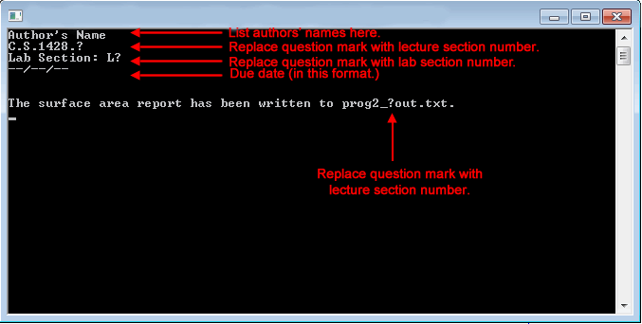

Example layout for file output should look like the following:

